**Tentative Schedule**

Monday- Move In/Set Up

Tuesday- Sweepstakes

Obedience

Seminars

Hospitality

Wednesday- Begin dogs & bitches

Agility

Top 20

Thursday- Cont. dogs & bitches

Title Parades

Rescue Parade

Rally

Annual Meeting

Friday- Non-Reg dogs & bitches

Junior Showmanship

Winners Dog & Bitch

Auction

Saturday- Breed Judging

Banquet

**October**

**27-31, 2015**

**C:\Users\Stephanie Barnhill\AppData\Local\Microsoft\Windows\Temporary Internet Files\Content.IE5\MC0LGHAM\MC900151205[1].wmf**

Kansas Expocentre  
One Expocentre Drive  
Topeka, Kansas

66612-1442

**Back to the Wild Wild West….**

**Kansas Expocentre**

* 210' X 255'
* 44,500 sq ft floor space
* Floor pockets contain both 208 volt single phase and 208 volt 3-phase

and 110 volt sources including both 20 and 30 amp service.

* Perimeter wall has multiple circuits with 110 volt and 20-amp service.
* Concrete floor
* Roll Doors
* Loading dock
* Faucet attachments located on loading dock for bathing
* Expocentre is surrounded by grassy walking areas that are lit for night time walking

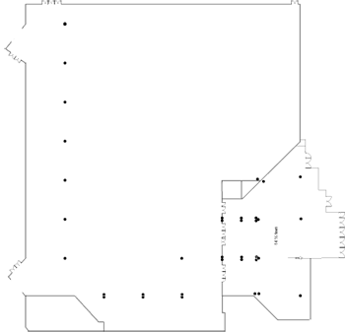E

**Domer Arena**

* Event Floor: 120’ wide x 175’ long filled with competition rodeo dirt. Concrete side aprons are 15’ wide and concrete south end apron is 24’ wide.
* High output T-5 Florescent lighting laid out in grid fashion from vaulted ceiling
* Cattle panels are 5’ high and are used around the perimeter of the dirt
* Dirt prepared for soft pack
* Located on the West side of Expocentre

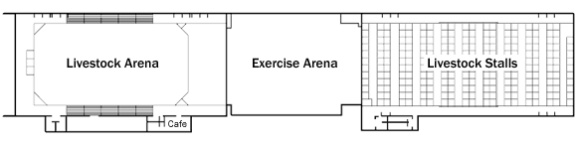

**Capital Plaza Hotel**

* $99.00 per night room rate
* $50.00 one-time pet fee
* 4 dogs per room allowed
* Complimentary wireless high-speed Internet
* Non-smoking hotel
* [Pet friendly](http://www.capitolplazahoteltopeka.com/amenities/pet-friendly)
* [Accessible rooms available](http://www.capitolplazahoteltopeka.com/accommodations/ada)
* Water Fall Grill
* Water’s Edge Lounge
* Room Service
* Laundry service
* Indoor pool, Whirlpool, Sauna
* Sundeck
* Fitness center

